ASSIGNMENT 2.2 22BCA136

Q1. Write a while loop in python that print numbers from 1 to 20.

# -*- coding: utf-8 -*-

"""

Created on Wed Jul 24 13:32:52 2024

@author: 8student6

"""

i = 1

while i<=20:

print(i)

i=i+1

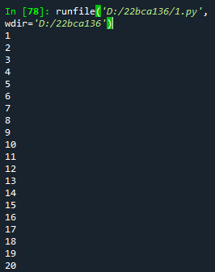

Q2. Write a while loop to calculate the sum of the first 50 positive integers.

i = 1

sum = 0

while i<=50:

sum = sum+i

i=i+1

print(sum)



Q3. Write a python program with while loop to Print the multiplication table of a given number

up to 10

i = 1

number = int(input("Enter number for which you want to print Table : "))

while i<=10:

print(number," * ",i," = ",(number*i))

i = i+1

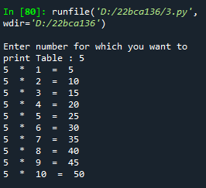

Q4. Write a while loop in python that print only even numbers from 1 to 50.

i = 1

while i<=50:

if(i%2==0):

print(i)

i = i+1

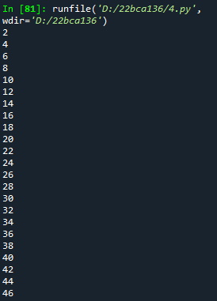

Q5. Write a python program with while loop to Count the number of vowels in a given string

using a while loop.

i = 0

count = 0

str = input("Enter Your String : ")

while i < len(str):

if str[i] in ['a', 'e', 'i', 'o', 'u','A','E','I','O','U']:

count = count+1

i = i + 1

print(count)

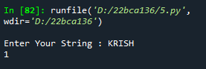

Q6. Print a number pattern using a while loop.

e.g.

1

1 2

1 2 3

1 2 3 4

1 2 3 4 5

i = 1

while i < 6:

j=1

while j<=i:

print(j, end=(" "))

j=j+1

print()

i=i+1

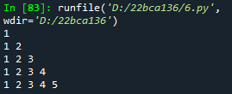

Q7. Print a following pattern using a while loop.

* * * * *

* * * *

* * *

* *

*

i = 1

while i < 6:

j=6

while j>i:

print(end=("* "))

j=j-1

print()

i=i+1

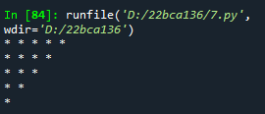

Q8. Write a program to Print Only Uppercase Letters in a String with while loop.

e.g text=’Hello Class’

output: H,C

str = input("Enter String : ")

i = 0

while i < len(str):

if(str[i].isupper()):

print(str[i],end=(" "))

i=i+1

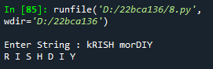

Q9. Write a program to Skip Non-Digit Characters in a String.

e.g text= ‘a1b2c3’

output=’abc’

str = input("Enter String : ")

i = 0

while i < len(str):

if(str[i].isalpha()):

print(str[i],end=(" "))

i=i+1

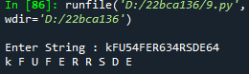

Q10. Write a program to ask user to enter password. If valid then print Access granted

otherwise print access denied and ask to re-enter. Max 3 times user can re-enter the password

i = 0

while i < 3:

str = input("Enter String : ")

if(str == "Admin"):

print("Access Granted .")

break

else:

print("Pass is not valid")

i=i+1

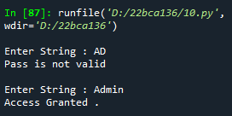

Q11. Write a python program to provide features of simple ATM machine to users like

withdraw, deposit and end operation (exit). Keep asking user with this features as option and

work based on user input.

atm = 50000

while True :

print("If you want to deposit the money than enter 1 \n if you want to withdraw enter 2\n if you want to end the task enter 3.")

n = int(input("Enter Your choice : "))

if(n==1):

a = int(input("Enter Your Amount of deposit : "))

atm=atm+a

elif(n==2):

a = int(input("Enter Your Amount of withdraw : "))

if(a>atm):

print("Not sufficiant Balance in ATM")

else:

atm=atm-a

elif(n==3):

print("exit")

break;

else:

print("Invalid input")

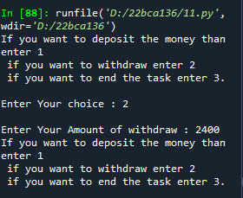

Q12. Write a program to print positive numbers from 1 to 50 with for loop.

for i in range(0,51,1):

print(i)

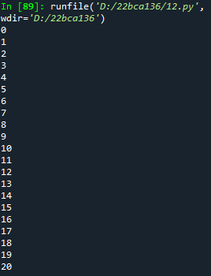

Q13. Write a program to print even numbers till 50 with for loop.

for i in range(0,51,1):

if(i%2==0):

print(i)

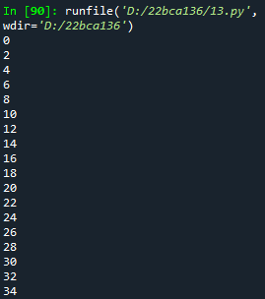

Q14. Write a program to print odd numbers till 50 with for loop.

for i in range(0,51,1):

if(i%2!=0):

print(i)

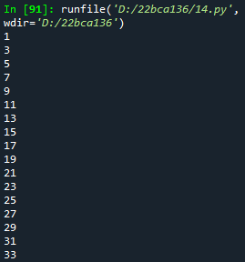

Q15. Write a program to print sum of all numbers till 50 with for loop.

sum = 0

for i in range(0,51,1):

sum =sum+i

print("sum = ",sum)



Q16. Write a program to print each character of the string with for loop.

str = input("Enter String : ")

for i in str:

print(i)

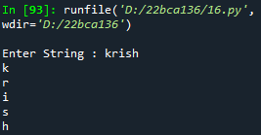

Q17. Write a program to find length of string with for loop (do not use len() function).

str = input("Enter String : ")

count = 0

for i in str:

count = count+1

print(count)

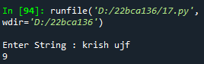

Q18. Write a python program to Count the number of vowels in a string with for loop.

Q18. Write a python program to Count Digits, Letters, and Special Characters in a String.

digit = 0

letter = 0

special = 0

str = input("Enter String : ")

for i in str:

if (i.isalpha()):

letter = letter+1

elif(i.isdigit()):

digit = digit+1

else:

special = special+1

print("Digit = ",digit)

print("Letters = ",letter)

print("Special = ",special)

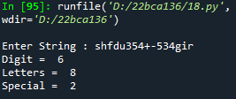

Q19. Write a program to Check if All Characters in a String are Unique.

str = input("Enter String : ")

flag = 0

for i in range(len(str)):

for j in range(i+1,len(str)):

if(str[i]==str[j]):

flag = 0

break;

else:

flag = 1

if (flag==0):

print("String is no unique : ")

else:

print("String is unique.")

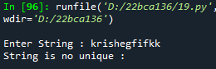

Q20. Write a program to Find the Most Frequent Character in a String.

f = 0

m = 0

str = input("Enter String : ")

c = str[0]

for i in range(len(str)):

for j in range(i+1,len(str)):

if (str[i]==str[j]):

f = f+1

if(f > m):

temp = f

f = m

m = f

c=str[i]

print("Most frequant char is = ",c)

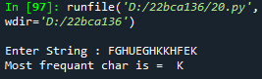

Q21. Write a program to Remove All Spaces from a String.

str = input("Enter String : ")

str1 = str.replace(" ", "")

print(str1)

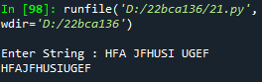

Q22. Write a program to Find the Position of All Vowels in a String.

str = input("Enter String : ")

for i in range(len(str)):

if(str[i]=='a' or str[i]=='o' or str[i]=='e' or str[i]=='i' or str[i]=='u' or str[i]=='A' or str[i]=='O' or str[i]=='E' or str[i]=='I' or str[i]=='U'):

print("index of ",str[i]," is ",i)

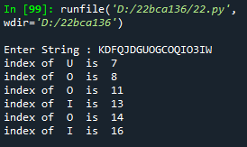

Q23. Write a program to get each characters of 2 string together using for loop.

e.g a=’abc’

x=’xyz’

output:

a x

b y

c z

str= input("Enter String : ")

str1 = input("Enter String 2 : ")

for i,j in zip(str,str1):

print(i,j)

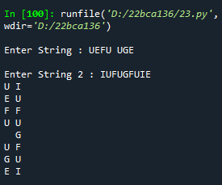

Q24. Write a python program to Combine Characters from Two Strings Alternatingly.

e.g a=’abc’

x=’xyz’

ax=’axbycz’

str= input("Enter String : ")

str1 = input("Enter String 2 : ")

str3 = ""

for i,j in zip(str,str1):

str3=str3+i+j

print(str3)

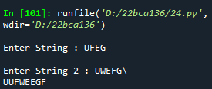

Q25. Write a program to Compare Two Strings for Common Prefix.

str= input("Enter String : ")

str1 = input("Enter String 2 : ")

count = 0

for i,j in zip(str,str1):

if(i==j):

count = count+1

if count > 1:

print("It has common prefix.")

else:

print("It not has common prefix.")

